**Introduction**

Nowadays, computer games are include into sports as eSports. eSports are include League of Legends (LOL), Counter-Strike: Global Offensive (CSGO) ,Defend of the Ancient 2 (DotA 2) and etc …

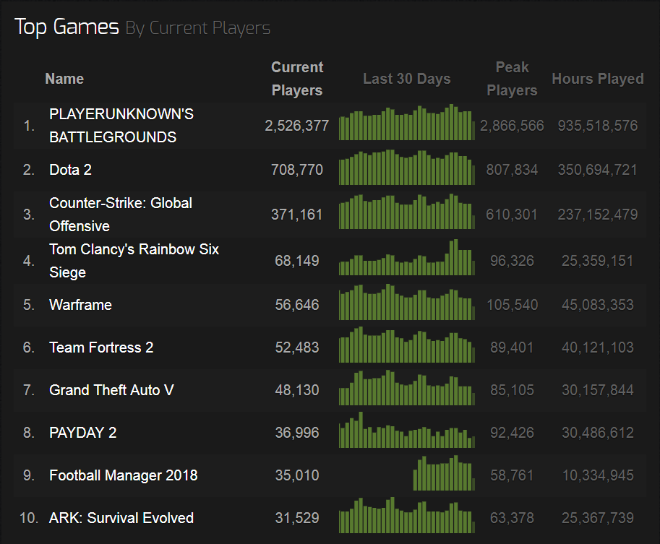

*Figure 1.0 Ranking List*

Base on Figure 1.0, we know that Dota 2 currently have 708,770 players in Steam platform which is ranked as 2nd. Also we could know that in last 30days there is total 807,834 players peaking on this game.

Moreover, eSports will be considered as a medal events in 2024 Olympics Games according The Guardian which is a daily newspaper in British.

The International Olympic Committee (IOC) is expected to held 2024 Games at Paris.

Co-president of Paris bid committee Tony Estanguet plans to have some talk to the IOC and the eSpotrs executives about the plans to include competitive video gaming as an official sport.

2024 Olympic Games program had be formed on 2019 with the final decision coming after Olympics in Tokyo on 2020.

Screenshot of the Website

There is a sign in page which let members to sign in and get some free discount which members to use it at current website.

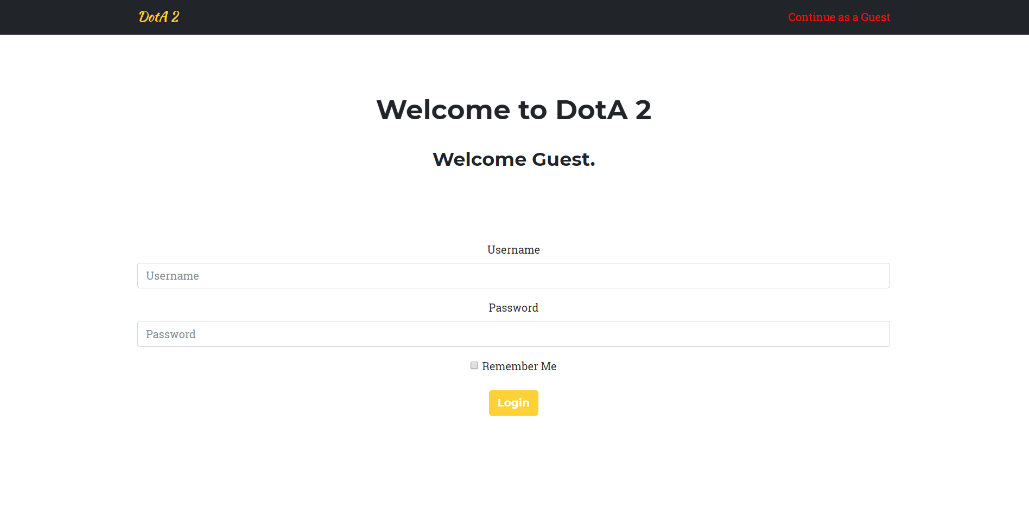

*Figure 2.0 Sign in page*

Members are allow to log in to this page by key in their register username and password.

Users which are not members could also access to this page by click ‘Continue as a Guest’ at the top-right corner to access the page and do not get the free voucher to get discount.

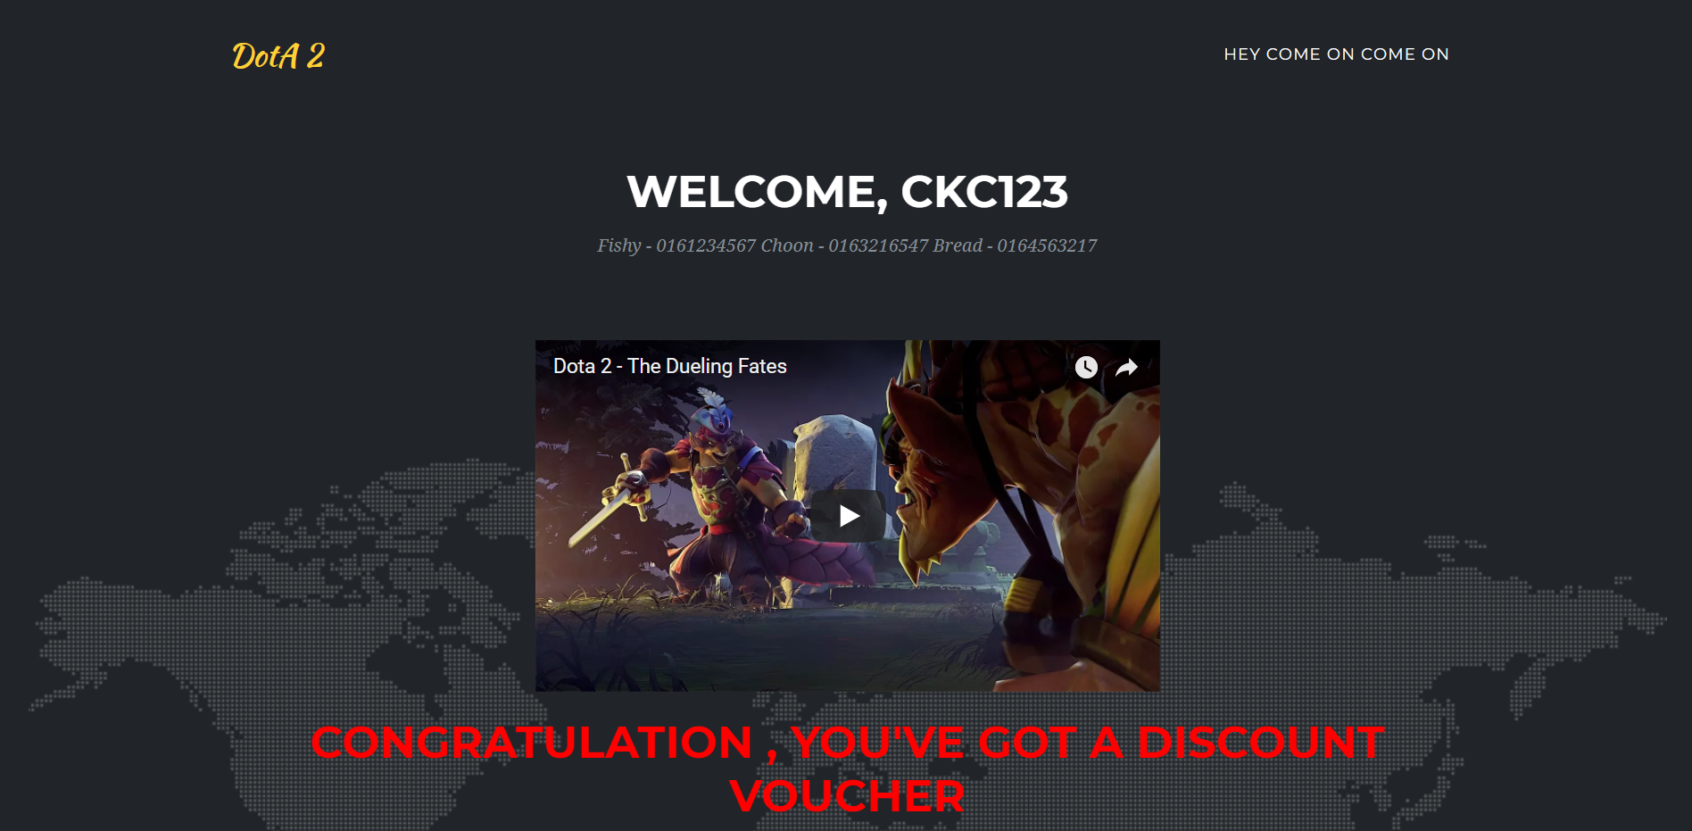

*Figure 2.0 Member login page*

After a member login to the page, it will show currently updated video about DotA 2 and also will show member’s register name and welcome them.

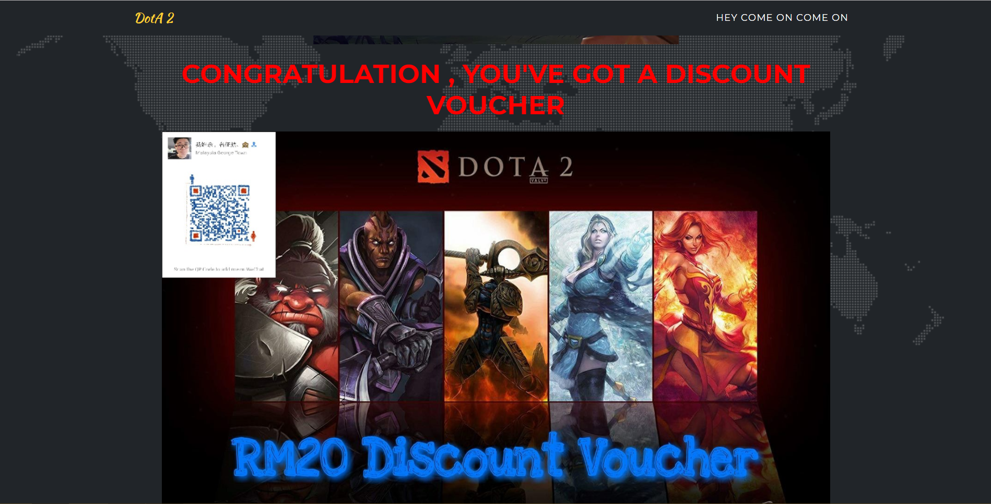

*Figure 2.1 Member login page*

Below the video and Welcoming, there is a QR-code for user to scan and add official Wechat for contact to use discount voucher.

*Figure 2.1 Member login page*

**HOME PAGE**

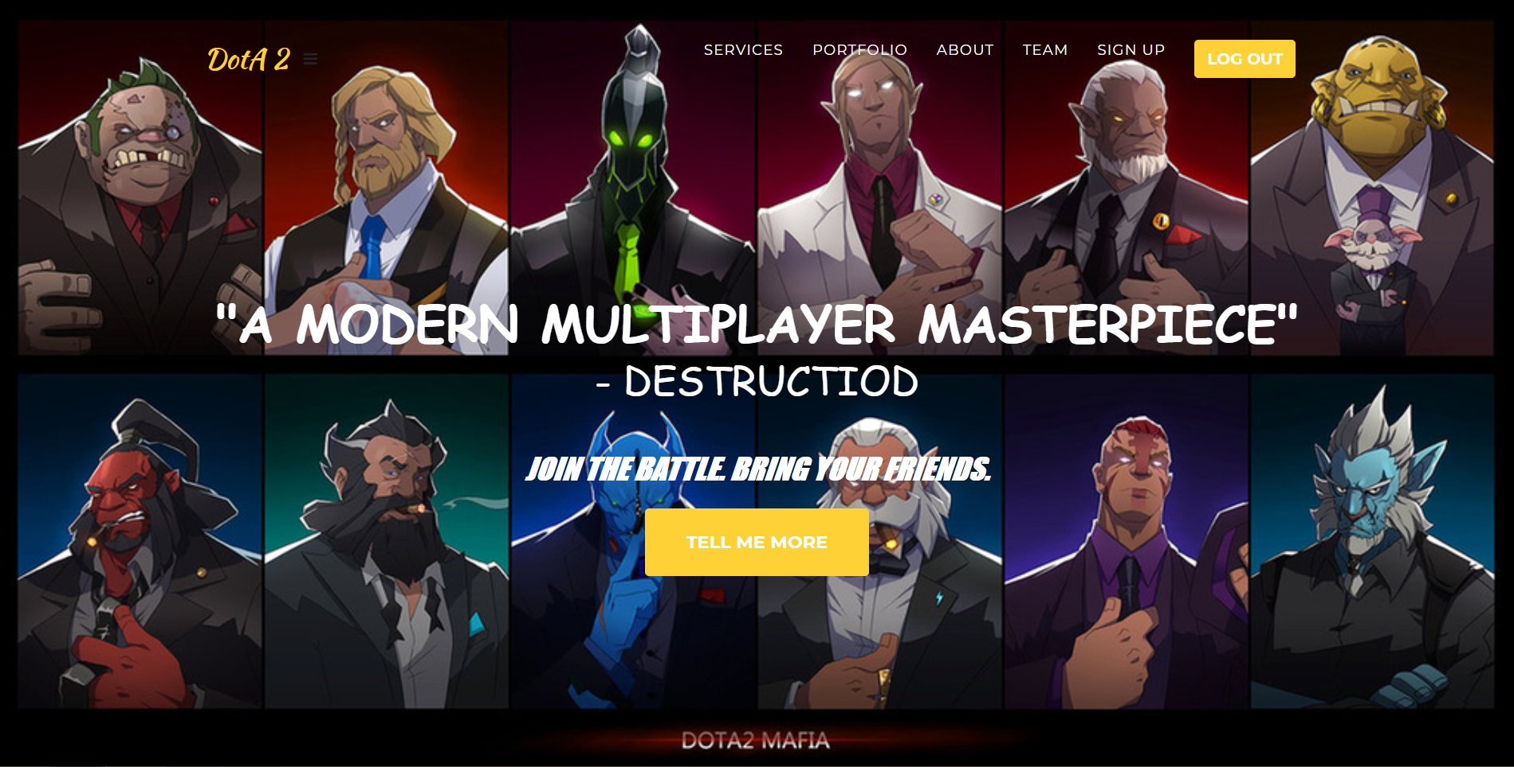

*Figure 3.0 MainPage*

If user is log in, on the top-right corner will be shown log out button.

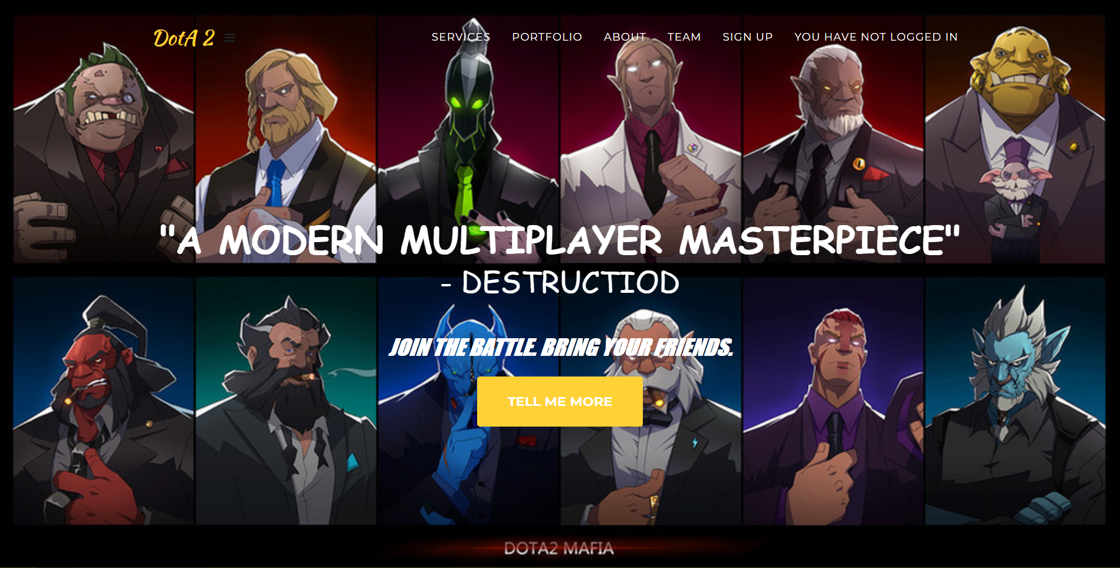

*Figure 3.1 MainPage*

If user is continue as guest, there will be shown that ‘you have not logged in’.

**SERVICES**

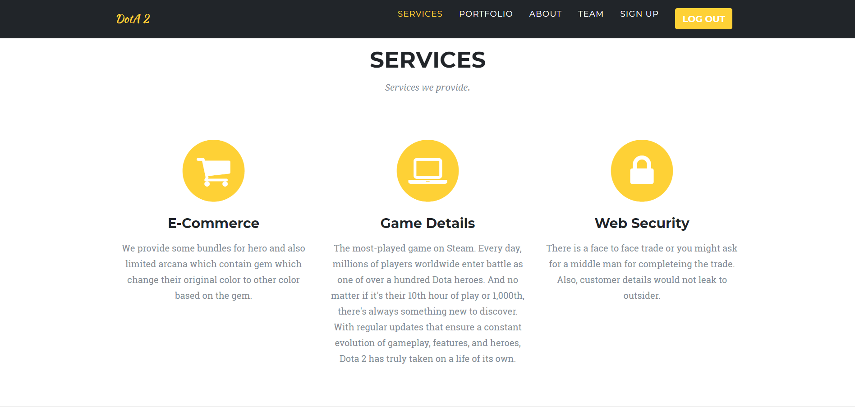

*Figure 4.0 Services Page*

Listed and show users what services we provided in this page.

**PORTFOLIO**

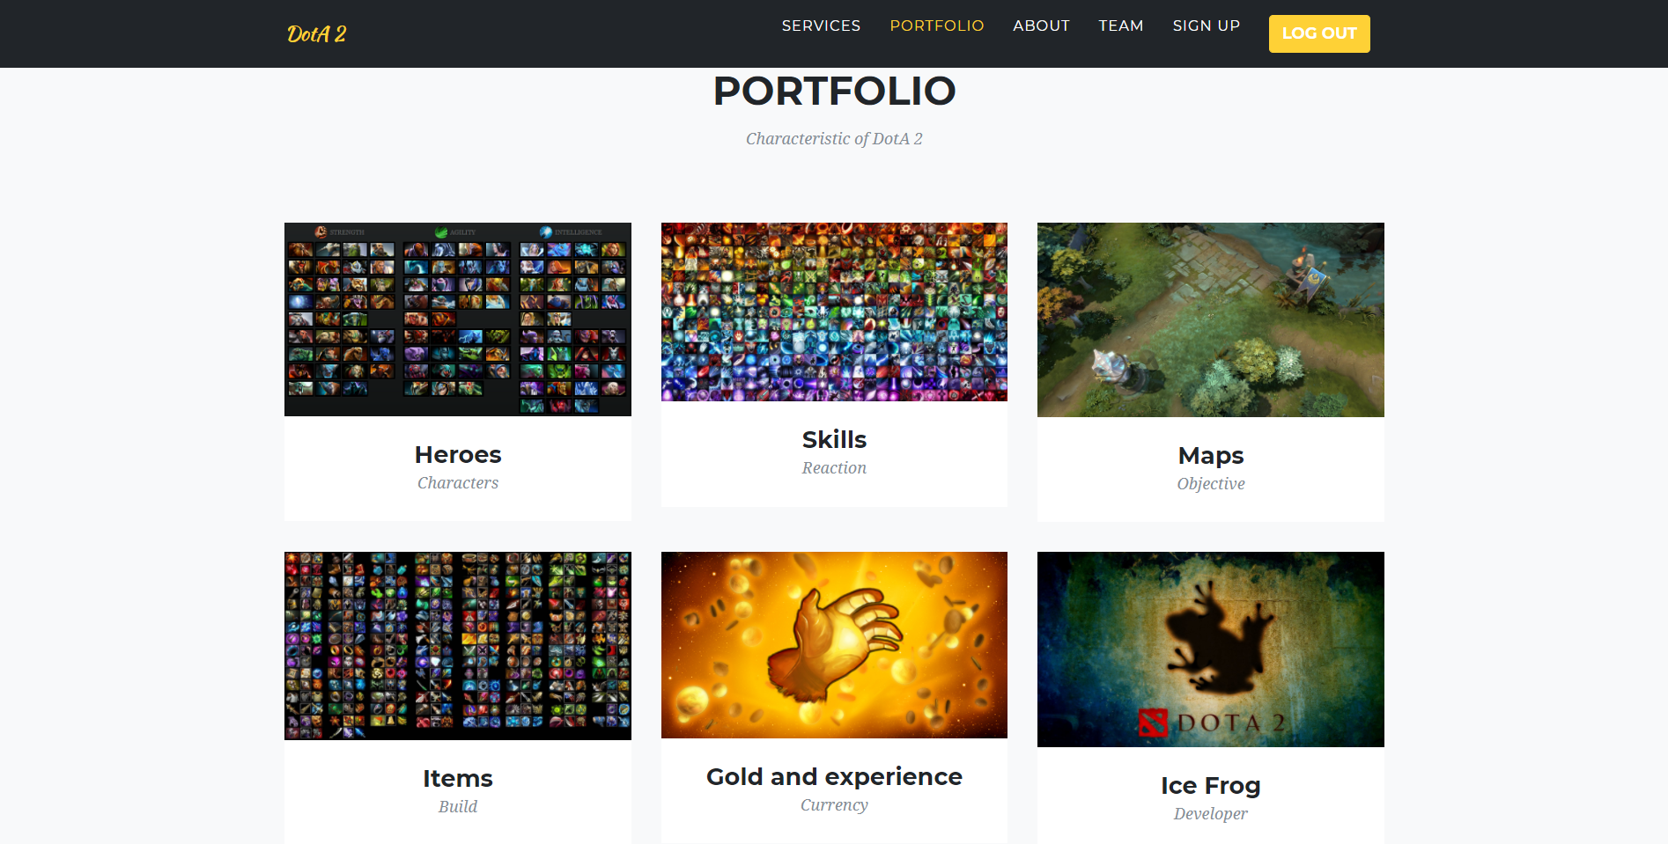

*Figure 5.0 Portfolio*

Characteristic for the main title ( DotA 2), if users need more information of specific details, users is allow to click on the picture and it will prompt out as Figure 5.1.

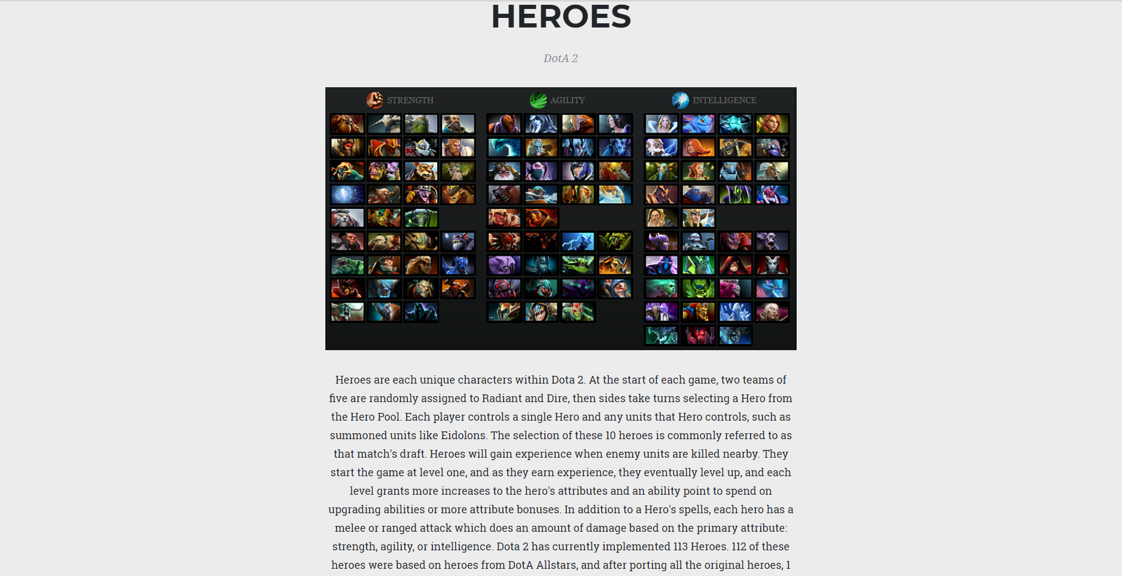

*Figure 5.1 Portfolio Info*

User could get more information on specific category that user clicked on it.

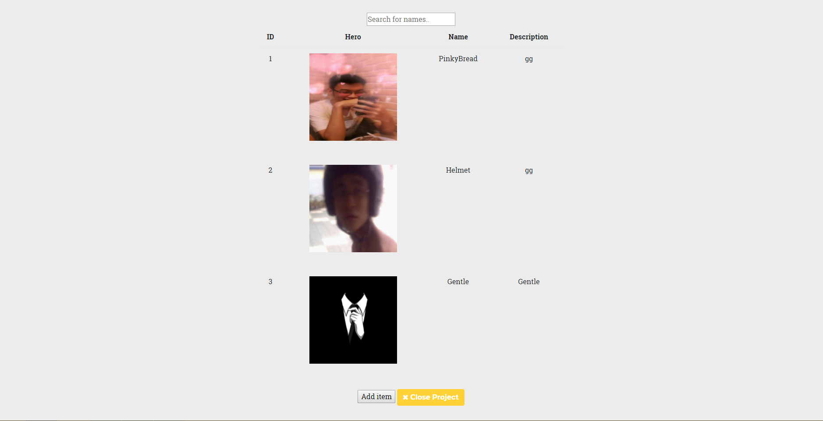

*Figure 5.2 Portfolio Info (Admin)*

If admin is logged in, admin have the right and permission to add item to the Hero list when DotA 2 officially update new hero to their list, our admin could also update the hero list to the website.

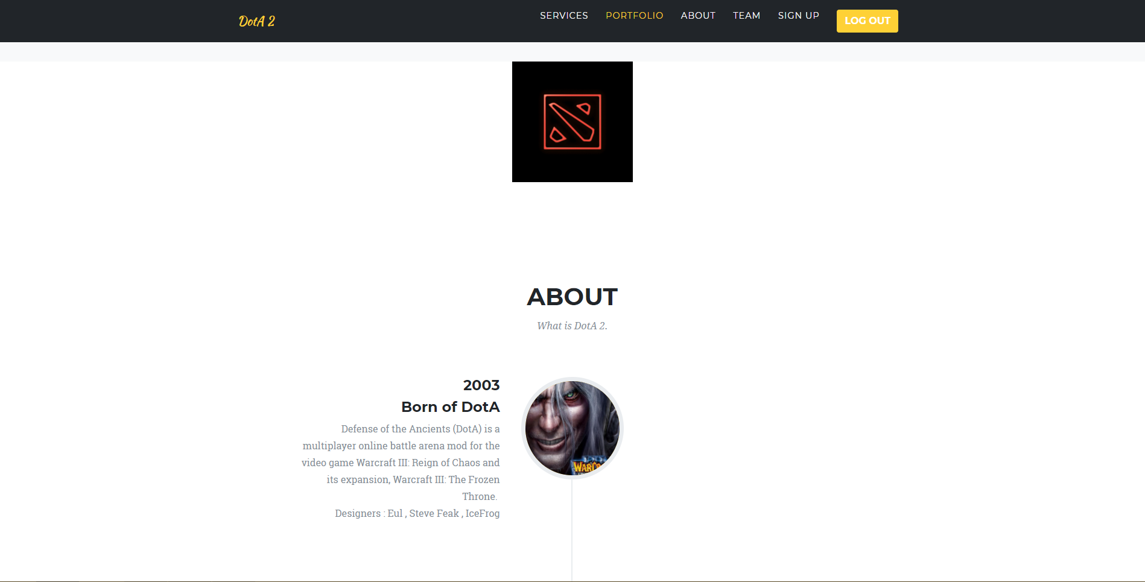

*Figure 6.0 about page*

A list of history and story of Dota 2.

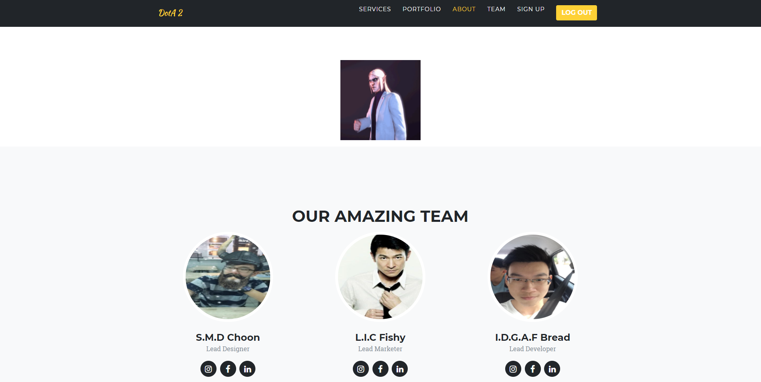

*Figure 7.0 team page*

Our Amazing team of this website.

Provided link to facebook , instagram.

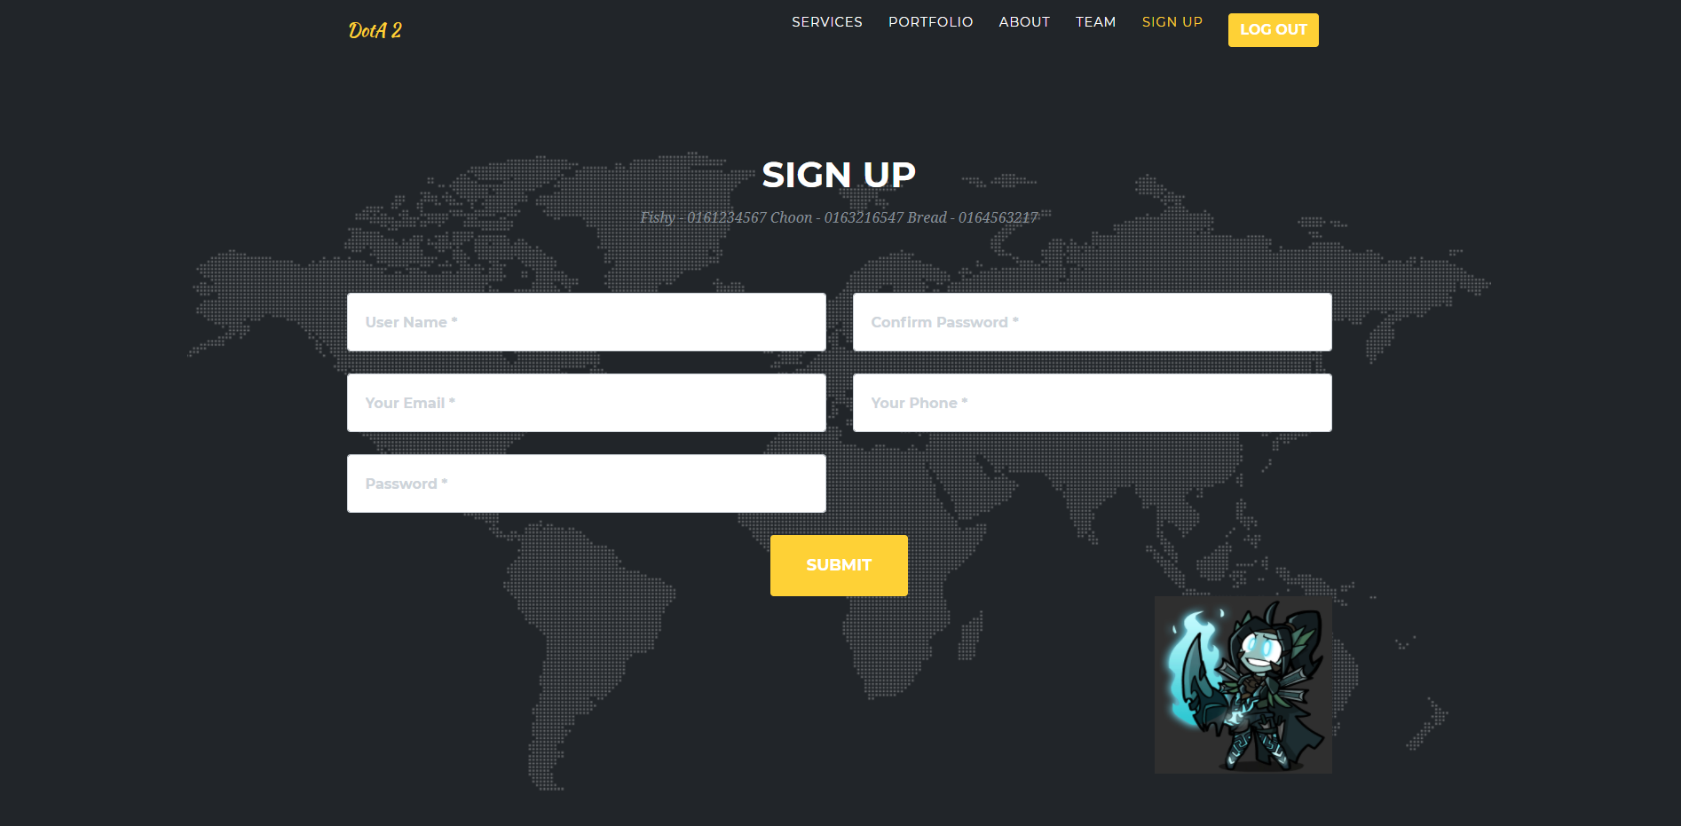

*Figure 8.0 sign up page*

Let non-member user to sign up as members.

Username is their name for this website.

Password is to secure the user’s account, while they key in password and confirm password, it will prompt as single black dot to hide their password in visual. Confirm Password is to confirm the previous user entered password was correct match.

The purpose of email is to get user’s email address and easy for admin send their newest feeds to their website.

Phone number is to let admin easy to contact current user if needed.

**Error Handling Section**

Index.php

If username column typed in which username is existed will be prompt username is existed.

If user left some blanks behind, it will prompt a message to inform user to key in.

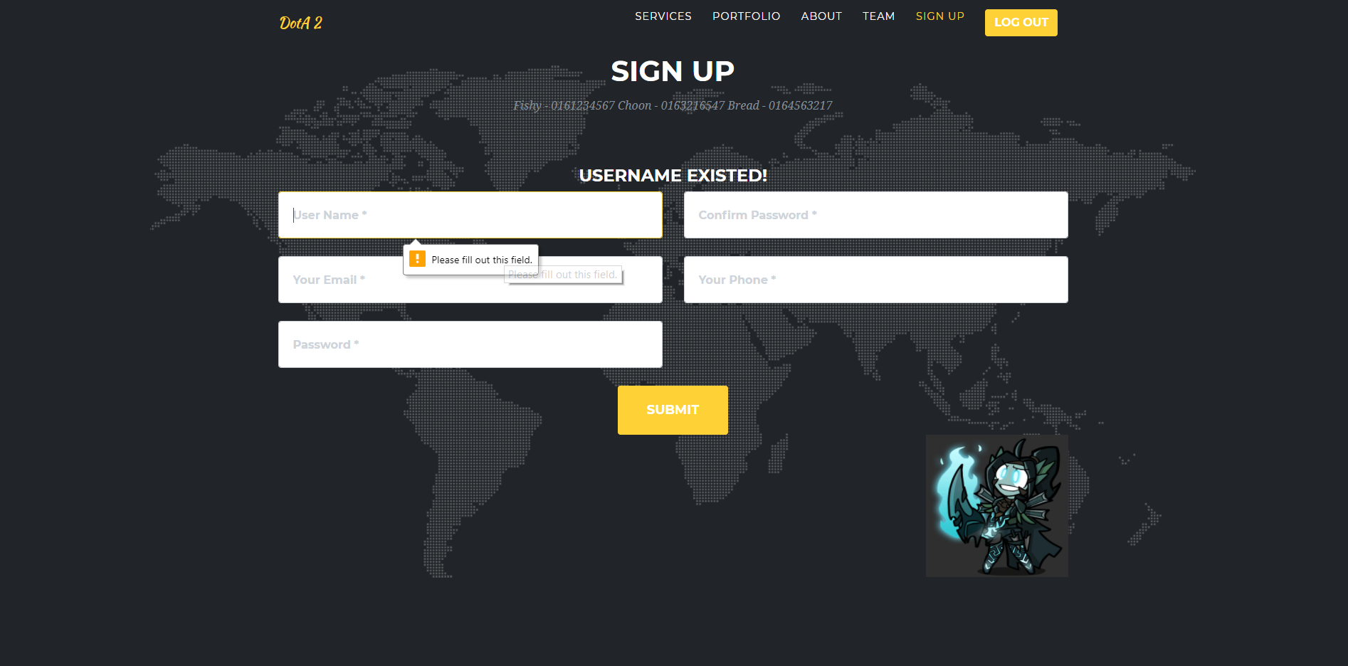

Signin.php

Username and password need to write correct to log in. Error will be shown if incorrectly enter username or password. 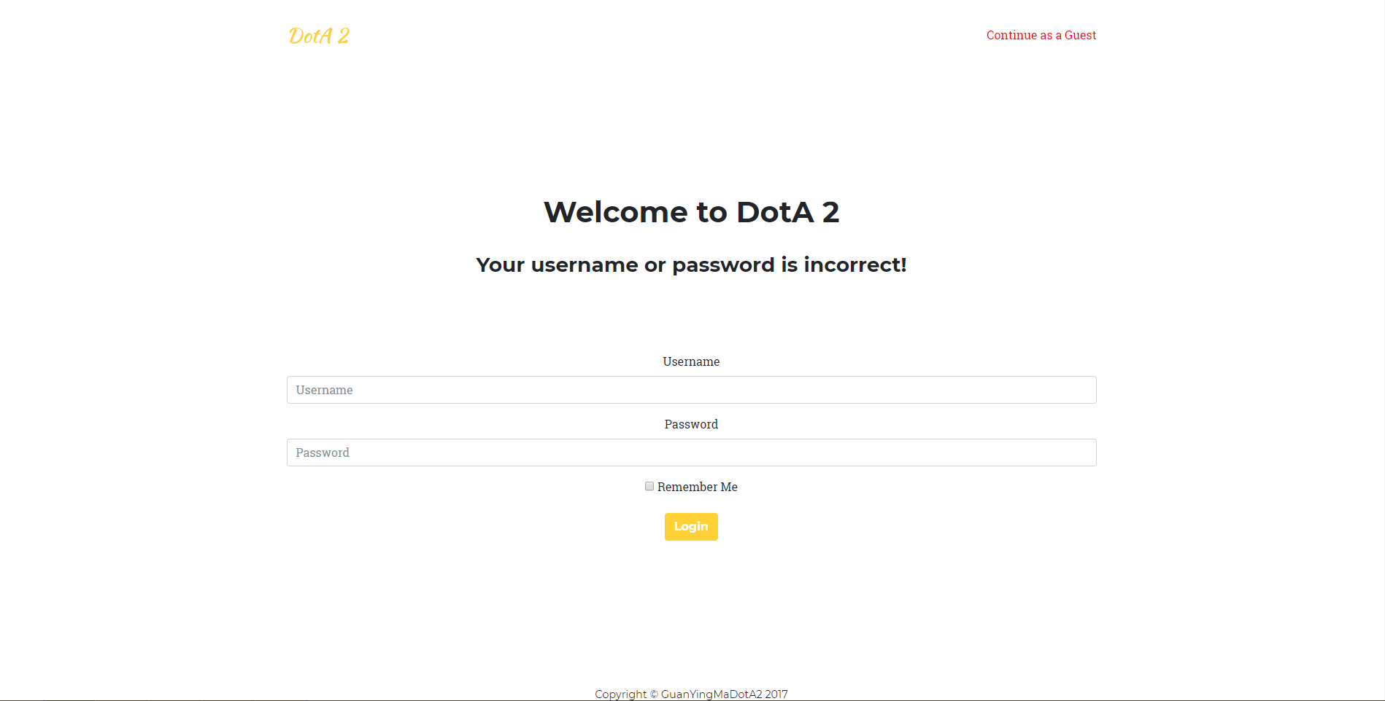

JavaScript / JQuery

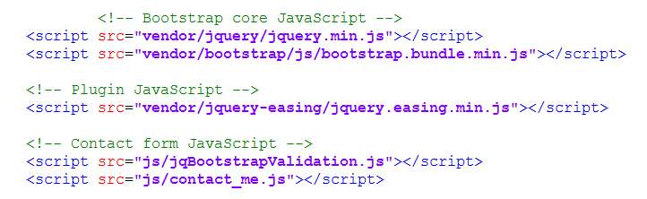

Signup.php

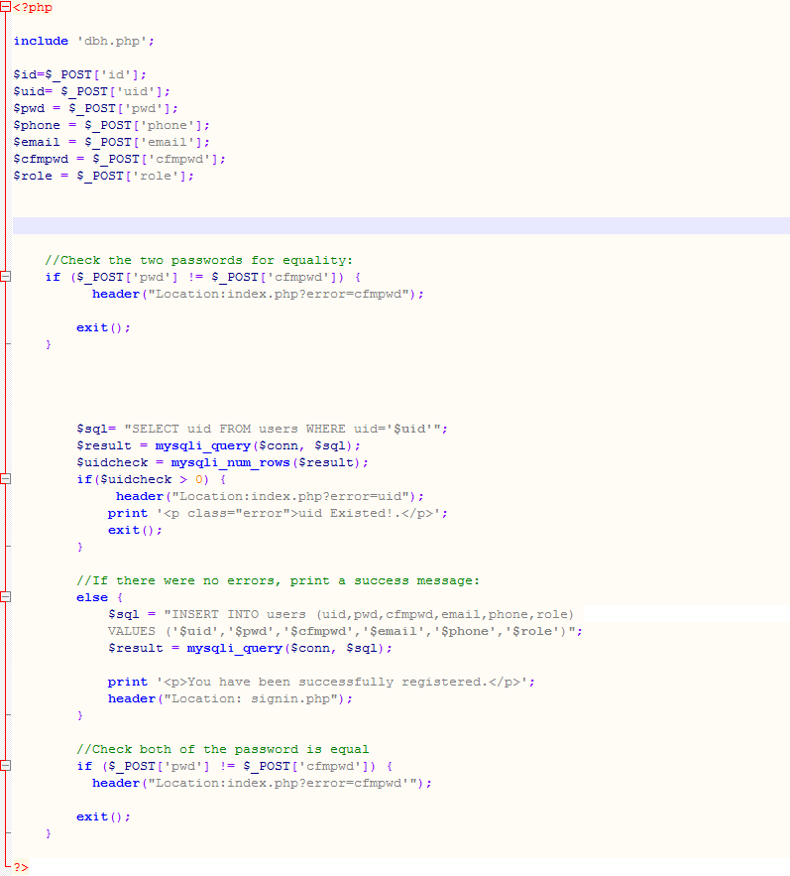

Login.php

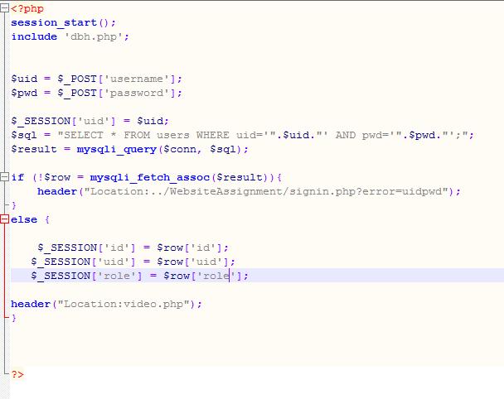

Logout.php

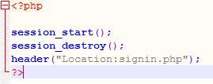

Registered user’s data will be store into database.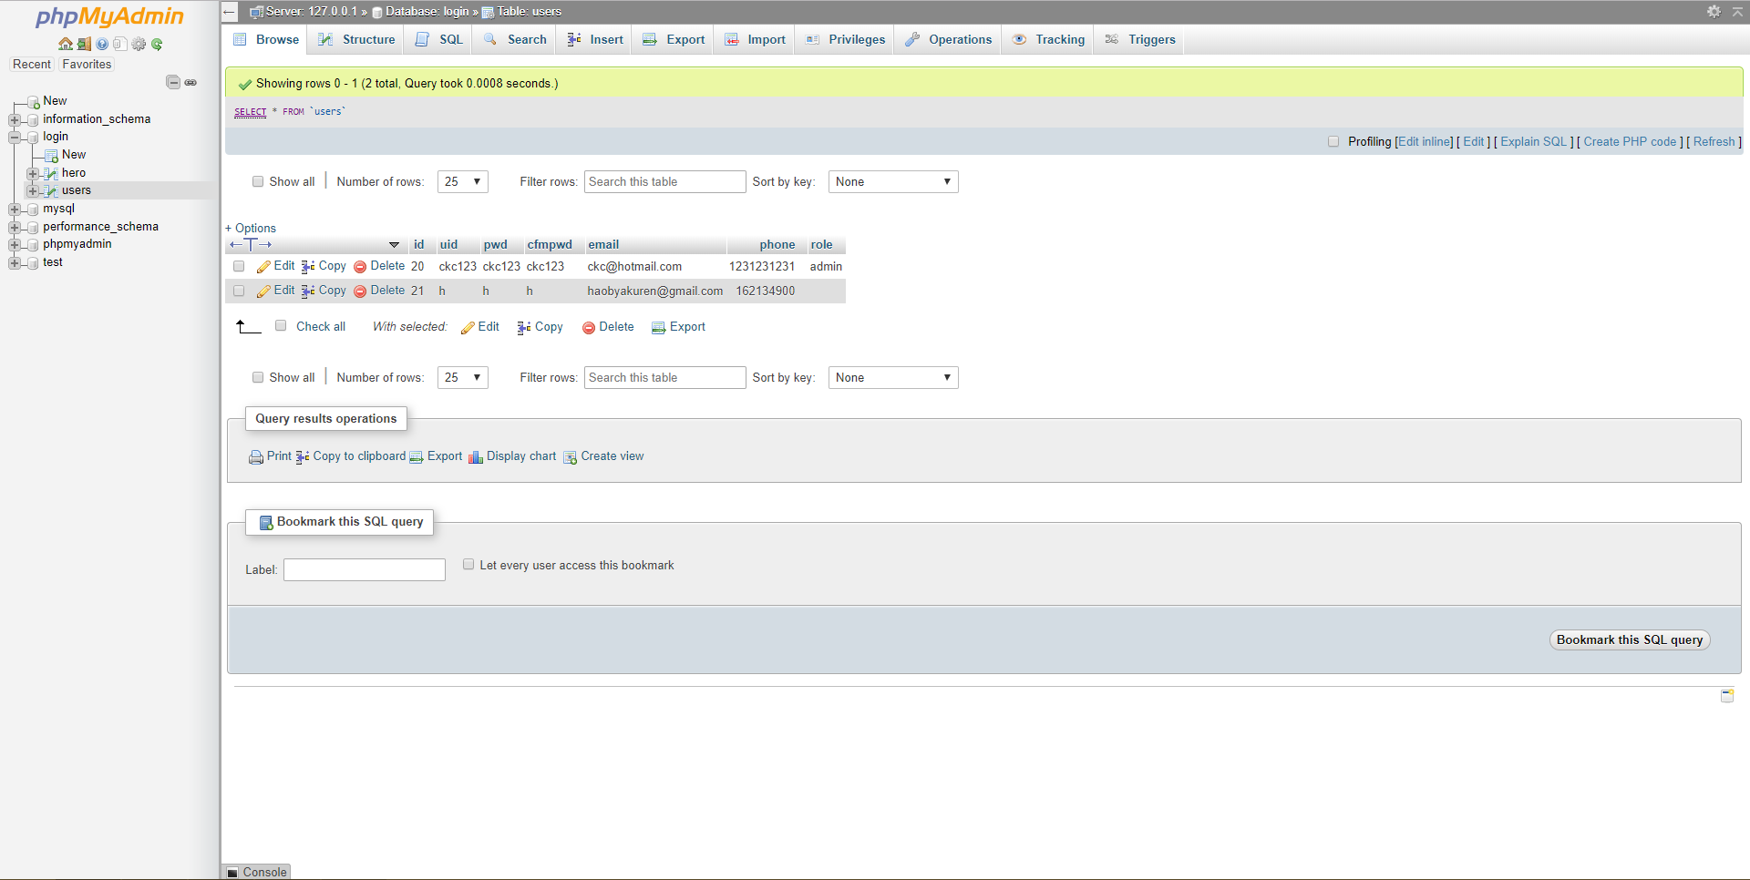

Uid = Username;

Pwd = Password;

Cfmpwd = Confirm password;

Email = email;

Phone = Telephone number;

Role = either Admin or not;

**Reflective**

In this project, I feel grateful to my lecturer – Ms Chern.

Who taught me a lot of knowledge about website and the coding function, also she help me on my website when I met some error and the code is not functioning.

Also my friend who help me overcome problem while I meet some problems and errors.

When either of my friend or Ms Chern are not around, I try to solve by myself and detect the error of my coding by internet.

**Strength**

The website that I created include register, login, uploading data.

Users can register their personal id for the website. The data will be store to specific database to let user could login to their profile when they visit the next time.

User can know more about the title of this website and the details of this website by clicking those specific image.

Also, user could buy in-game items by contact those people which listed down in the website.

**Weakness**

This website couldn’t auto send email to users.

Users couldn’t leave comment to this page as some feedback.

Background music could not keep auto looping.

Users couldn’t get a add to cart function to let user easy to buy items.

**Future Enhancement**

There will be a shopping cart function for users.

This function will let users more easily to keep or buy their items.

Admin will have a comment page to let users give some feedbacks by commenting and admin is allow to reply them as well.

**Conclusion**

Conclusion, I learned how to create a website by myself with some function I learned from Ms Chern, my lecturer, my friends and some by internet.

Mostly the function are based on PHP code, although these are all just simple function which able me to create a simple website, but I will keep working on it make it become a better and flexible website.

In additional, I’ve manage to connect my PHP to MYSQL database and I apply them on log in page and log out page also register page.

I have also learn few difference way to design and make my website good looking. There are still wide area for me to discover in this website coding. I would like to keep moving and learn more about the coding way to make my website more professional and usable in society.